Awards are in season for Cambridge schoolgirl poet Aminah Rahman, nominated for national prize
By Cambridge News | Posted: November 04, 2015
- 
Aminah Rahman
VIEW GALLERY
Comments (0)
The works of Roald Dahl proved inspiration for a young Cambridge poet, who is in the running for a national writing award.
12-year-old Aminah Rahman, pictured, has been shortlisted for the annual Young Muslim Writers Awards, for her series of three seasonal poems.
She told the News: "I wrote three poems about seasons, winter, autumn and summer. They were rhyming poems and it did take me a few days, but I eventually got them right."
She will now attend an awards ceremony hosted by the Muslim Hands organisation, where the winners of the contest, which is open to Muslim writers aged five to 16, will be announced.
RELATED CONTENT
- Boy, 11, found after going missing from school trip near Cambridge
- Keen cyclist Alan Baldwin is new Deputy Chief Constable for Cambridgeshire
- Girls accused of Exning arson attack bailed to Crown Court
- Tucker Gardner in Ely taking part in Samaritan’s Purse’s Operation Christmas Child campaign
- Cambridge youngster makes giant paper chain to raise money for school friend with cerebral palsy
She said: "I'm really looking forward to the ceremony.
"The deadline was late July and it took about two to three months to find out whether I had been shortlisted, so it was very exciting, as I have never been shortlisted for anything like this before."
Her poems, which were written when she was a pupil at Arbury Primary School, have been entered in the Key Stage 2 poetry category, alongside four other young poets.
Forty writers have been shortlisted for the eight categories.
Their submissions have been assessed by an internationally renowned panel of judges including Carnegie Medal winner Tim Bowler, Louis de Bernières, author of Captain Corelli's Mandolin and playwright and poet Gillian Clarke.
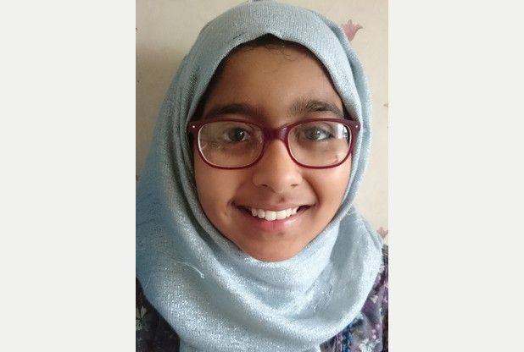
For Aminah, who now attends Chesterton Community College, the nomination is the first step on the road to a future career as a writer.
She said: "When I am older I would like to write my own books, and possibly illustrate them as well, so it starts from here. I would like to write about food, because there's a lot of detail in it."
Her introduction to poetry came at Arbury Primary.
"In my English classes we did do a lot of poetry, and we studied famous poets, which was quite fun", she said.
"I quite like Roald Dahl. I like how he does a twist in the poem, it's about a classic fairy tale but he changes it at the end, and I really like his one about Red Riding Hood.
"I do find him an inspiration, but I came up with my own poems."
Her mother, writer and publisher Shahida Rahman, said she was thrilled her daughter was following in her footsteps.
"She has always been into writing from a young age", she said.
"It's nice to have someone follow me."
Presented in association with the Yusuf Islam Foundation and now in their fifth year , the awards will be broadcast live on the Islam Channel on December 5.
Syed Lakhte Hassanain, chairman of Muslim Hands, said: "Time and again young writers impress us beyond measure with their creativity and writing talent.
"The selection process is always an incredibly enjoyable yet challenging stage of the competition as the quality of writing is continuously improving.
"This proves that through nurturing the aspirations and celebrating the achievements of young people we can help create an environment where they can flourish."
For more about the awards, and their annual creative writing workshops, see here.

Spring
Spring, spring is coming soon
The grass is green and the flowers bloom.
The wind's loud song is heard, day after day
And the leaves break free from the trees, and start to sway.
Flowers dance side to side,
Whilst giving the buzzing bees a rocking ride.
The sky holds blue and so clear,
Ever so perfect, anyone would want to be here!
Spring makes the world a pleasant place
And you see huge smiles on every face.
Flowers grow and birds arrive,
Oh, isn't it amazing to be alive!

Autumn
Descending leaves fall to the ground,
Twirling, twisting, round and round,
Autumn is almost here,
The smell of freshness is ever so near.
The strong gush of wind will blow my silky hair,
Cutting through the cool and chilly air.
Leaves fall like kisses from the wide, blue sky,
Which fall from a place, so so high!
The crisp and bitter breeze
Shakes the leaves from the tall and towering trees,
Gold and brown is all that can be seen,
As autumn takes away the appealing green.

Winter
Winter crept through the darkening wood
Passing holly and oak.
He crushed each leaf, never stood
And never a word he spoke.
The streets were like frosted cakes,
The houses were covered in glowing snow,
All cars were covered with delicate snowflakes
And the white began to grow.
The next day the snow disappeared,
It suddenly began to rain
Everything speck of white had cleared
And never came back again.

Read more: http://www.cambridge-news.co.uk/Awards-season-Cambridge-schoolgirl-poet-Aminah/story-28107804-detail/story.html#ixzz3r6eZ0Vuj
Follow us: @CambridgeNewsUK on Twitter | cambridgenews on Facebook

